Honeycomb Investment Trust plc

28 February 2022

# Investment Manager’s Commentary

**Key Details**

|  |  |
| --- | --- |
| Monthly NAV Return (Annualised) | 7.7% |
| Monthly NAV Return | 0.59% |
| YTD NAV Return | 1.28% |
| ITD* NAV Return | 51.2% |
| NAV Cum. Income | £363.9m |
| NAV Ex. Income | £361.8m |
| Market Capitalisation | £299.7m |
| Net Investment Assets | £579.9m |
| Net Debt to Equity | 58.7% |
| Debt to Equity | 68.2% |
| Shares in Issue | 35,259,741 |
| Share Price | 850.0p |
| NAV Cum. Income per Share | 1,032.2p |
| NAV Ex. Income per Share | 1,017.8p |
| Premium (Discount) to NAV Cum Income | (17.6)% |

Honeycomb Investment Trust plc (the “Company”) delivered a NAV return of 0.59% for the month, which is equivalent to 7.7% per annum.

NAV return was driven by strong risk adjusted yield of 9.1% with no impairment charge in the month due to the continued strength in performance of the portfolio. In line with previous years the result was impacted slightly by February being a short month, with interest accruing on a day count basis on the majority of underlying investments.

Net Investment Assets were stable in the month (£579m in January, to £580m in February).

**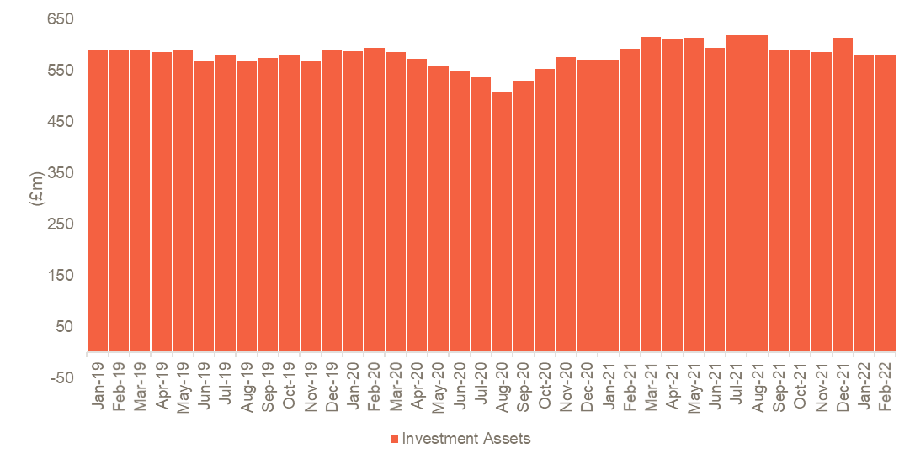Figure 2 - Composition of Investment Assets Figure 3 Investment Assets**

3 Net Investment Assets

**Figure 4 – NAV Stratification**

4 NAV excluding working capital and debt, stratified by investment structure

5 NAV excluding working capital and recourse debt, stratified by expected remaining term of each asset

6 NAV excluding working capital and debt, stratified by average yield of each platform

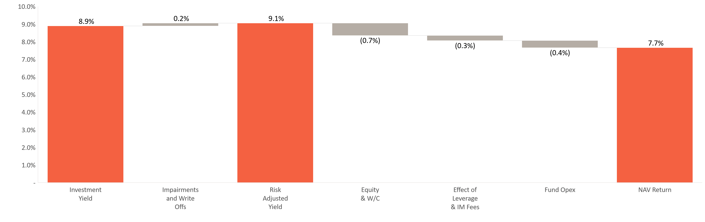**Figure 5 – February 2022 Returns Bridge**

**Figure 6– Top 10 Holdings**

**1**

Sancus Loans Limited

Structured

Senior

Short Term Property Loans

52.8

50%

9.1%

**2**

UK Agricultural Finance

Direct Portfolio

Senior

Short Term Property Loans

52.7

49%

9.1%

**3**

Oplo Direct Portfolio

Direct Portfolio

Secured

Secured Consumer

50.6

52%

8.7%

**4**

Creditfix Limited

Structured

Senior

Discounted Fee Receivables

45.7

82%

7.9%%

**5**

Downing Development Loans

Structured

Senior

Short Term Property Loans

37.8

65%

6.5%

**6**

Queen Street

Direct Portfolio

Senior

Short Term Property Loans

37.0

65%

6.4%

**7**

GE Portfolio

Direct Portfolio

Secured

Secured Consumer

30.2

62%

5.2%

**8**

Nucleus Cash Flow Finance Limited

Structured

Senior

SME

28.8

96%

5.0%

**9**

Duke Royalty

Structured

Senior

SME

28.6

40%

4.8%

**10**

Beaufort

Direct Portfolio

Senior

Short Term Property Loans

y

23.9

70%

4.1%

**Percentage of**

**Portfolio**

**(3)**

**Value of Holding**

**at 28-Feb-22 (£m)**

**Deal Type**

**(1)**

**Structure**

**Sector**

**LTV**

**(2)**

Statistics as at 28 February 2022

1. Direct Portfolios labelled as Senior in structure refer to portfolios of loans that are individually senior secured

2. In the case of Direct Portfolios, the LTV is against latest underlying collateral values (typically at origination for directly originated assets or at purchase for acquired seasoned portfolios). For structured facilities the LTV reflects the maximum advance rate against eligible assets for Oplo Structured and 118118 Loans, and in the case of structured property-backed facilities, the LTV reflects the look through LTV against the underlying property collateral. Development finance loan LTVs are quoted as the maximum LTGDV at origination. 3. Net Investment Assets

Background and Investment Objective

**Fund Facts**

|  |  |
| --- | --- |
| Type of Fund | Closed – Ended Fund |
| Listing | Main Market of the London Stock Exchange |
| Ticker | HONY |
| ISIN | GB00BYZV3G25 |
| Inception Date | 23 December 2015 |
| Dividend | Quarterly |
| NAV Calculation | As of last day, of each month |
| Management Fee* | 1% |
| Performance Fee** | 10% |
| * applicable to gross assets  ** subject to 5% preferred return hurdle and high watermark | |

Honeycomb Investment Trust plc (the “Company”) operates an asset backed credit strategy that delivers stable income alongside strong downside protection through providing predominantly senior lending to non-bank lenders secured on their underlying loan portfolios. The investment strategy is supported by the ongoing structural changes in the financial services industry that create a significant opportunity for non-bank lenders to reach customers who are underserved by mainstream banks with bespoke and appropriate products. The investment objective is to provide shareholders with an attractive level of dividend income with capital preservation.

The strategy aims to generate positive impact around key areas where Honeycomb Investment Trust can make a meaningful difference; Financial Inclusion, Affordable Housing, Regional Growth & Green Housing.

Investment Features

* 8% targeted dividend on issue price when fully invested and leverage applied, payable quarterly.
* Investments secured on loan portfolios of non bank lenders
* A diverse and granular portfolio, no single asset / single sector risk
* Short duration - Average life 2 to 3 years with underlying portfolio typically amortising removing refinancing/ exit risk
* Investments benefit from tight Covenants and Corporate security
* Conservative Leverage

**Performance & Dividend History**



(1) NAV return excluding effect of capital raise and issuance at a premium would have been 0.77%

(2) Inception to date NAV return affected by IFRS 9 initial recognition on 2018 brought forward retained earnings

(3) NAV return excluding effect of capital raise and issuance at a premium would have been 0.63%

(4) NAV return excluding effect of buy backs would have been 0.60%

* ITD: Inception to Date – excludes IPO Issue Costs

** Based on IPO Issue Price of 1000p

*** Recognised in the month when marked ex-dividend

**** Based upon the number of shares at the ex-dividend date

Important Disclosures

This newsletter is issued in the United Kingdom by Pollen Street Capital Limited. It is provided for the purpose of information only and should not be construed as constituting an offer, solicitation, invitation or inducement to buy or sell shares in Honeycomb Investment Trust plc (“the Company”). If you are unsure of the suitability of this investment you should take independent advice. All data in this factsheet is at or to the final day of the calendar month identified in the heading of the factsheet’s front page unless otherwise stated. Investors should read the prospectus or offering memorandum before investing in the Company.

Net Asset Value performance is not linked to share price performance and shareholders may realise returns that are lower or higher in performance.

Past performance should not be seen as an indication of future performance. The value of investments and any income may fluctuate, and investors may not get back the full amount invested. The views expressed are those of the Company’s Investment Manager, Pollen Street Capital Limited, as at the time of writing. These are subject to change without notice and do not constitute investment advice. Although the Company and Pollen Street Capital Limited have used reasonable efforts to ensure the accuracy of the information contained in this newsletter, neither the Company nor Pollen Street Capital Limited make any warranties or representations with respect to the completeness or accuracy of the information set forth herein and the full impact of Covid-19 on markets and investments may not be foreseeable for some time. Examples of investment process, risk management, due diligence, position sizes, diversification, leverage, assessment of risk and similar information (together, the “Investment Programme”) are presented as general guidelines used for illustration purposes only and are subject to change without notice to investors at any time at the sole discretion of Pollen Street Capital Limited. In addition, the composition and size of, and risks associated with, current or future investments of the Company may differ substantially from examples set forth in this newsletter. Accordingly, actual implementation of the Investment Program may vary from the examples presented herein.

This newsletter may not be distributed or transmitted in any jurisdiction outside the United Kingdom where such distribution may lead to a breach of law or regulatory requirements, or transmitted, distributed or sent to or by any national, resident, or citizen of any nation other than the United Kingdom. The distribution of this document in certain jurisdictions may be restricted by law and therefore persons into whose possession this document comes should inform themselves about and observe any such restrictions. Any such distribution could result in a violation of the law of such jurisdiction.

Pollen Street Capital Limited is authorised and regulated by the Financial Conduct Authority and is registered in England (reg. no. 08741640) with its registered office at 11/12 Hanover Street, London, England, W1S 1JJ.

Glossary

**NAV (Cum Income)** is the value of investments, other assets and cash, including current year revenue, less liabilities.

**NAV (Ex Income)** is the value of investments, other assets and cash, excluding current year revenue, less liabilities

**NAV Return** is calculated as NAV Cum. Income at the end of the period, plus dividends declared during the period, divided by NAV Cum. Income at the start of the period, calculated on a per share basis.

**Share Price** closing mid-market share price at month end (excluding dividends reinvested).

**Premium / (Discount)** the amount by which the price per share is either higher (at a premium) or lower (at a discount) than the NAV Cum. Income, expressed as a percentage of the NAV Cum. Income per share.

**Net Assets** total assets minus any liabilities.

**Market Capitalisation** the closing mid-market share price multiplied by the number of shares outstanding at month end.

**Debt to Equity** the value of total leverage including any accrued interest and fees divided by the NAV

**Annualisation Methodology** Monthly returns have been calculated by multiplying the actual number of days in the year divided by the actual number of days in the month.